|  |  |  |
| --- | --- | --- |
| Write an application in C++ using to use new and delete to manage dynamic memory. Implement the application by defining a suitable class and its member functions. | | |
| Requirement Tag | Requirement Description | Comments |
| OSTR/01 | Accept a sentence (that is a line) with a maximum of 5 words from the user. |  |
| OSTR/02 | Extract every word and store in an array of 5 char pointers dynamically allocating memory. | Hint: Use new (nothrow) and handle new allocation failures manually. Refer http://www.cplusplus.com/doc/tutorial/dynamic/ |
| OSTR/03 | Print the longest word in the sentence (assume all words are of different length). |  |
| OSTR/04 | Read a word and a replace word from user. Perform search-replace. (Replace only the first matching word). | Hint: While replacing, free the memory allocated for the searched word and then allocate new memory as per length of replace word. |
| OSTR/05 | Display all the words. |  |
| OSTR/06 | Free all the allocated memory on exit |  |

**OSTR/01**

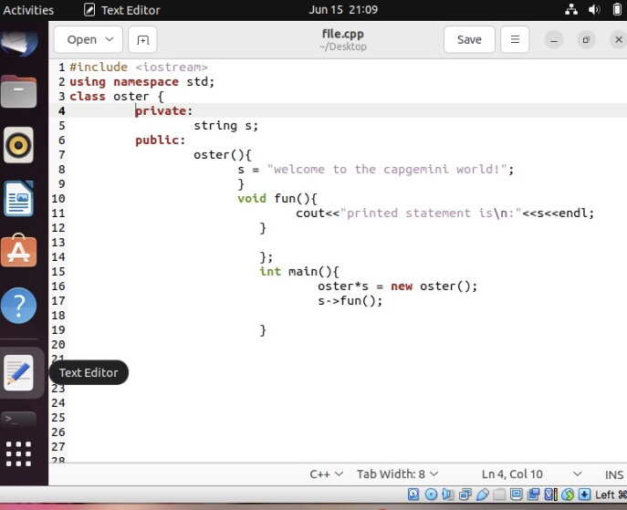

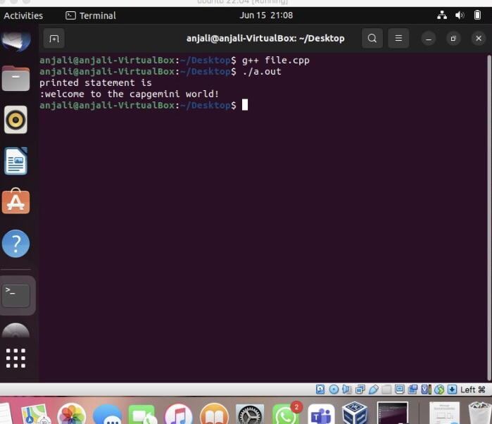

**OSTR/03**

**OSTR/03**

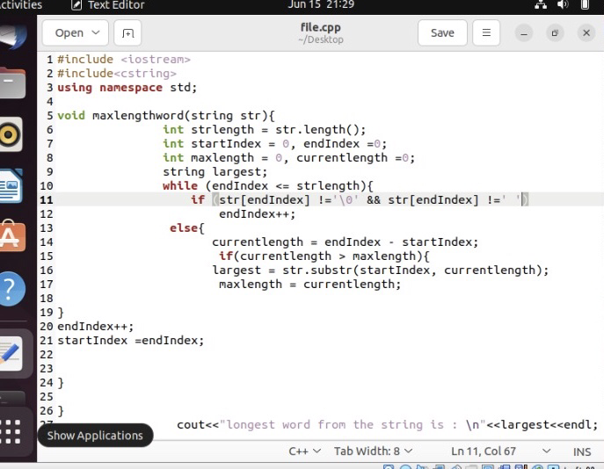

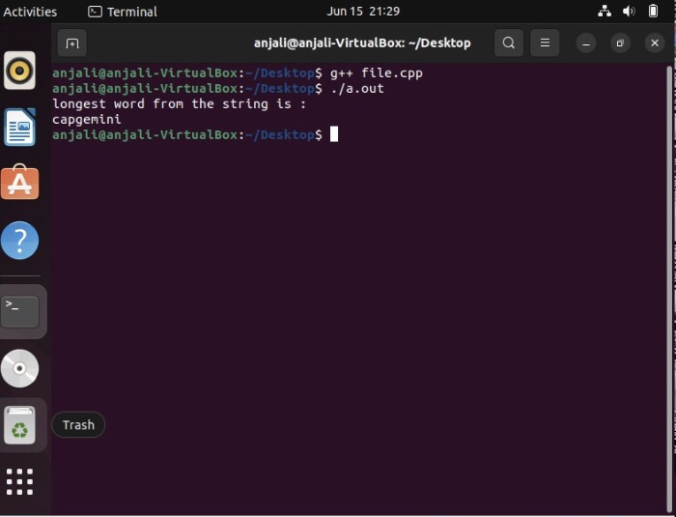

**OSTR/04**

